**Important Notes:**

* **Happy Birthday to Wakinyela February 18th!**
* **NO SCHOOL, Monday, February 20th**
* **PE days are Monday and Friday .**
* **Year Book Orders due Friday, February 24th.**
* **Check out day it Thursday.**
* **Spring Picture Day will be Tuesday, February, 28th. The selection form will be coming home on Tuesday.**

**Reader’s and Writer’s Workshop**

***Shared Reading:*** *We are reading* ***Harry McFarr’s Clunker Car*** *by* Jill Eggleton. Harry loves his car, but it is a true clunker! It makes so much smoke that a dragon would choke!

***Basal Textbook:*** This week we will read **The Tree.** This is a story from Poppleton Forever by Cynthia Rylant. In this story, Poppleton plants a tree in his yard. One day the leaves started to droop and the bark peels. Poppleton asks many friends how to make his tree better. Ask your child to tell you what Poppleton did to make his tree better.

**Skill:** This week we will be focusing retelling the story with key details.

**Writing:** We will continue writing How-To stories.



**Popcorn and Juice Party**

Thanks to the generous families in our classroom for donating items to the “Soup”er Bowl contest!! Our class donated the most items in the entire school! Therefore we won a popcorn and juice party, we will be having our treats at our Friendship Party on Tuesday! 

**Cultural Corner**

Word of the Week-Turtle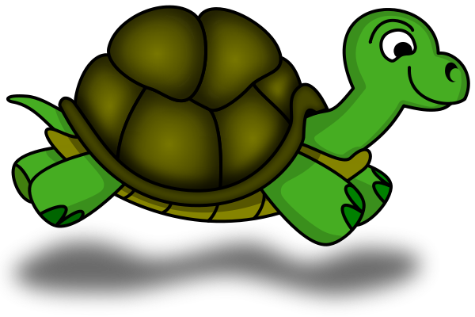

Lakota- **keya**

Spanish**-tortuga**

**Spelling/Word Work/Handwriting**

**Phonics Focus:** /ar/ & /or/  
**Spelling Test:** The spelling test for this week will be Thursday, February 16th. It will focus on words –r controlled vowels /*ar/.*

**Handwriting:** We will be reviewing letters Hh, Vv, and working on Keys to Legibility.

**Word Wall Words:** car, if, thing, or, night, come

**Math**

We will begin finish up Investigation 1 of Unit 6 with story problems with missing parts. In these problems students will be challenged to discover the missing number in a variety of positions of an equation. For example, we may be told the total amount but need to find the addend.

We will then begin Investigation 2: Combinations of Numbers

* Revisit How Many of Each problems-Question for students: Have you found all of the possible combinations in How Many of Each Problems? How do you know? An organized approach is helpful to finding all of the possibilities.